**BIKE CRASH DETECTION**

**A PROJECT REPORT**

***Submitted by,***

|  |  |
| --- | --- |
| Student Name | Roll Number |
| N. LIKHITH RAJ | 20201CST0149 |
| BANDI HEMANTH | 20201CST0105 |
| V. AJAY BHARGAV | 20201CST0104 |
| B. JAYADEEP REDDY | 20201CST0134 |
| K. SIVA MALLESWAR REDDY | 20201CST0101 |

*Under the guidance of,*

**Ms. Ankita Bhaurmik**

***in partial fulfillment for the award of the degree of***

**BACHELOR OF TECHNOLOGY**

**IN**

**COMPUTER SCIENCE AND TECHNOLOGY [ARTIFICIAL INTELLIGENCE AND MACHINE LEARNING]**



**PRESIDENCY UNIVERSITY**

**BENGALURU**

**JANUARY 2024**

**PRESIDENCY UNIVERSITY**

**SCHOOL OF COMPUTER SCIENCE AND TECHNOLOGY(AI&ML)**

**CERTIFICATE**

This is to certify that the Project report “**BIKE CRASH DETECTION**” being submitted by “N. LIKHITH RAJ, BANDI HEMANTH, V. AJAY BHARGAV, B. JAYADEEP REDDY, K. SIVA MALLESWAR REDDY” bearing roll number(s) “20201CST0149, 20201CST0105, 20201CST0104, 20201CST0134, 20201CST0101” in partial fulfilment of requirement for the award of degree of Bachelor of Technology in Computer Science and Engineering is a bonafide work carried out under my supervision.

|  |  |
| --- | --- |
| **Ms. ANKITA BHAURMIK**.  Assistant professor-  School of CSE  Presidency University | **Dr. JAYACHANDRA**  A-Prof. & HOD-  School of CSE  Presidency University |

|  |  |  |
| --- | --- | --- |
| **Dr. C. KALAIARASAN**  Associate Dean  School of CSE&IS  Presidency University | **Dr. SHAKKEERAL**  Associate Dean  School of CSE&IS  Presidency University | **Dr. Md.SAMEERUDDIN KHAN**  Dean  School of CSE&IS  Presidency University |

**PRESIDENCY UNIVERSITY**

**SCHOOL OF COMPUTER SCIENCE ENGINEERING**

**DECLARATION**

We hereby declare that the work, which is being presented in the project report entitled **BIKE CRASH DETECTION** in partial fulfilment for the award of Degree of **Bachelor of Technology in Computer Science and Technology [Artificial Intelligence and Machine Learning]** ,is a record of our own investigations carried under the guidance of **Ms. Ankita Bhaurmik**, **Assistant Professor, School of Computer Science Engineering & Information Science, Presidency University, Bengaluru.**

We have not submitted the matter presented in this report anywhere for the award of any other Degree.

|  |  |
| --- | --- |
| **Names**  **N. LIKHITH RAJ**  **BANDI HEMANTH**  **V.AJAY BHARGAV**  **B. JAYADEEP REDDY**  **K. SIVA MALLESWAR REDDY** | **Roll number Signature**  **20201CST0149**  **20201CST0105**  **20201CST0104**  **20201CST0134**  **20201CST0101** |

**ABSTRACT**

The frequent reports of accidents attributed to impaired driving, often characterized by unstable conditions and compromised parameters, this project aims to address a pressing road safety issue, specifically concerning two-wheeler vehicles. The initiative focuses on the creation and deployment of an innovative Bike Crash Detection system, designed to mitigate the risks associated with bike accidents. This project delves into the forefront of technological advancements, leveraging sophisticated sensor networks and a meticulously crafted algorithm. The objective is to pioneer advanced bike safety tech by using smart sensor networks and a customized algorithm. The goal is a robust system swiftly identifying and responding to bike crashes in real-time. Unlike the traditional methods, our unique algorithm empowers sensors to recognize critical situations and automatically send SOS signals, ensuring quick and precise communication. This approach combines precision engineering and innovative tech for improved two-wheeler safety. The project's outcomes reveal compelling capabilities in precisely identifying bike crashes and prompt initiation of responses. This marks a significant stride in advancing road safety for two-wheeler vehicles. The Bike Crash Detection system not only underscores the potential of technology-driven solutions but also serves as a pivotal step toward establishing safer road environments. Beyond its immediate applications, this project provides valuable insights and practical implications for the effective implementation of bike crash detection systems. It stands as a catalyst for fostering innovation and progress within the domain of transportation safety.

**ACKNOWLEDGEMENT**

First of all, we indebted to the **GOD ALMIGHTY** for giving me an opportunity to excel in our efforts to complete this project on time.

We express our sincere thanks to our respected dean **Dr. Md. Sameeruddin Khan,** Dean, School of Computer Science Engineering & Information Science, Presidency University for getting us permission to undergo the project.

We record our heartfelt gratitude to our beloved Associate Deans **Dr. Kalaiarasan C and Dr. Shakkeera L**, School of Computer Science Engineering & Information Science, Presidency University and **Dr. A. JAYACHANDRAN**, Head of the Department, School of Computer Science Engineering & Information Science, Presidency University for rendering timely help for the successful completion of this project.

We are greatly indebted to our guide **Ms. Ankita Bhaurmik**, School of Computer Science Engineering & Information Science, Presidency University for her inspirational guidance, and valuable suggestions and for providing us a chance to express our technical capabilities in every respect for the completion of the project work. We would like to convey our gratitude and heartfelt thanks to the University Project-II Coordinators **Dr.Sanjeev P Kaulgud,Dr. Mrutyunjaya** **MS** and also the department Project Coordinators **Dr. Manjula H M, Mr. Yamanappa**.

We thank our family and friends for the strong support and inspiration they have provided us in bringing out this project.

|  |
| --- |
| **N. LIKHITH RAJ** |
| **BANDI HEMANTH** |
| **V. AJAY BHARGAV** |
| **B. JAYADEEP REDDY** |
| **K. SIVA MALLESWAR REDDY** |

**1CST0149**

**LIST OF FIGURES**

|  |  |  |  |
| --- | --- | --- | --- |
| **Sl. No.** | **Figure Name** | **Caption** | **Page No.** |
| 1 | Figure 1.1 | ROAD ACCIDENT DEATH IN INDIA | 8 |
| 2 | Figure 2.1 | Handlebar Switch | 21 |
| 3 | Figure 2.2 | Apple AirTag, Samsung Galaxy SmartTag | 21 |
| 4 | Figure 3.1 | Architecture Diagram | 24 |
| 5 | Figure 4.1 | Arduino UNO | 27 |
| 6 | Figure 4.2 | GSM | 29 |
| 7 | Figure 4.3 | Accelerometer | 30 |
| 8 | Figure 4.4 | Gyroscope | 30 |

**ANTH.**

|  |  |  |  |
| --- | --- | --- | --- |
|  | **CHAPTER NO.** | **TITLE** | **PAGE NO.** |
|  |  | **ABSTRACT** | **4** |
|  |  | **ACKNOWLEDGEMENT** | **5** |
|  |  | **LIST OF FIGURES** | **6** |
|  |  |  |  |
|  | **1.** | **INTRODUCTION** | **8** |
|  |  | 1.1 INTRODUCTION | **9** |
|  |  |  |  |
|  | **2.** | **LITERATURE REVIEW** | **12** |
|  |  |  |  |
|  | **3** | **RESEARCH GAPS OF EXISTING**  **METHODS** | **14** |
|  |  |  |  |
|  | **4** | **PROPOSED METHODOLOGY** | **15** |
|  |  |  |  |
|  | **5** | **OBJECTIVES** | **18** |
|  |  |  |  |
|  | **6** | **SYSTEM DESIGN & IMPLEMENTATION** | **19** |
|  |  |  |  |
|  | **7** | **TIMELINE** | **24** |
|  |  |  |  |
|  | **8** | **OUTCOMES** | **25** |
|  |  |  |  |
|  | **9** | **RESULTS AND DISCUSSIONS** | **26** |
|  |  |  |  |
|  | **10** | **CONCLUSION** | **29** |
|  |  |  |  |
|  |  | **REFERENCES** | **30** |
|  |  |  |  |
|  |  | **APPENDIX-A** | **31** |
|  |  | **APPENDIX-B** | **32** |

**TABLE OF CONTENTS**

# CHAPTER-1

# INTRODUCTION

# Road safety is a paramount concern in today's fast-paced world, with a particular emphasis on mitigating the risks faced by two-wheeler vehicles. One significant contributing factor to accidents involves instances of impaired driving, where operators are often unable to maintain stable conditions and critical vehicle parameters.

# The rapid growth of technology has made our easier this advancement in technology also increased traffic hazarded. Hence ratio of road accident increases. Most of the Time loss of life due to poor emergency facilities. Our research provide a solution for accident detection and preventation of human life safety.

# This introduction provides an overview of the project's core focus, emphasizing the need for innovative solutions in the realm of road safety, especially for vulnerable road users like two-wheeler riders. The subsequent sections of the report will delve into the technological aspects, methodologies, challenges encountered, and the anticipated impact of the Bike Crash Detection system.

# 

As per the 2015 report, the cumulative number of registered motor vehicles in India has surpassed 21 million. The country recorded 22,536,000 car users, and approximately 17.6 million two-wheelers were sold to consumers in 2017. Alarming statistics reveal that India witnesses 1214 road crashes daily, with two-wheeler accidents constituting 25% of total road crash fatalities. A recent survey highlights Tamil Nadu as the state with the highest number of road crash injuries. Illustrated in Figure 1.1 is the 2016 Accident Report of Indian Roads. Tragically, one road accident-related death occurs every four minutes in India

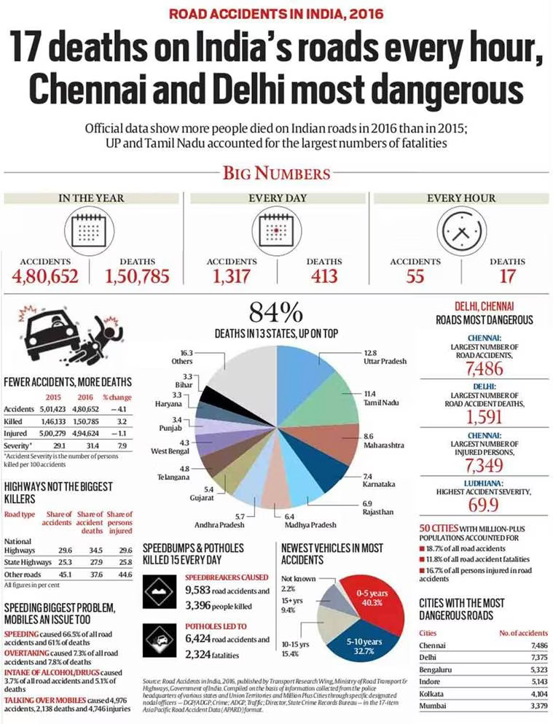

Figure 1.1-Road accidents in india,2016

# Technology Utilized:

**Hardware:**

The project employs an Arduino board, specifically the ESP32 model, as its primary hardware component. Integrated with sensors includes accelerometer, gyroscope, and a GSM module.

**Software:**

The programming language utilized for the embedded system is Embedded C. This language serves as the foundation for developing the software components of the system, ensuring seamless integration and efficient functioning of the implemented technology.

In response to the alarming rise in road accidents and the critical need for swift emergency response, our project introduces an innovative Vehicle Crash Detection System. This intelligent system leverages cutting-edge components, including a GSM module, accelerometer sensor, gyroscope sensor, and a versatile extra port for future sensor integration through a female USB socket. The inclusion of a battery port, coupled with a female USB socket for charging convenience, ensures the system's continuous operation and accessibility in various scenarios.

**Components:**

* **GSM Module:** The GSM module serves as the communication hub, enabling real-time transmission of crucial information. In the event of a vehicular accident, this component facilitates the prompt relay of accident details, including location data, to designated emergency contacts and authorities. This ensures swift response times, potentially minimizing the impact of accidents on individuals involved.
* **Accelerometer Sensor:** The accelerometer sensor plays a pivotal role in detecting sudden changes in the vehicle's acceleration, indicative of a collision or crash. This real-time data enables the system to promptly identify accidents, triggering the necessary emergency protocols. By continuously monitoring the vehicle's acceleration, the accelerometer enhances the system's accuracy in detecting critical events.
* **Gyroscope Sensor:** Complementing the accelerometer, the gyroscope sensor contributes to a comprehensive understanding of the vehicle's movement dynamics. It provides essential data on rotational movements and orientation changes, offering a more nuanced perspective on potential accidents. The gyroscope sensor enhances the overall accuracy and reliability of the crash detection system.
* **Extra Port for Future Sensors (Female USB Socket):** Anticipating future advancements in sensor technologies, our system incorporates an extra port through a female USB socket. This modular design allows for seamless integration of additional sensors, expanding the system's capabilities and adaptability to emerging technologies. This forward-looking approach ensures the system remains relevant and upgradable.
* **Battery Port and Female USB Socket for Charging:** To guarantee uninterrupted functionality, the system includes a dedicated battery port and a female USB socket for easy recharging. This design choice promotes portability and convenience, allowing users to charge the system using standard USB chargers. The inclusion of these ports ensures sustained operation, even in areas with limited power infrastructure.

This Vehicle Crash Detection System, with its advanced components, not only addresses the urgent need for rapid accident detection but also establishes a foundation for future enhancements and sensor integrations, positioning it as a versatile and forward-thinking solution in the realm of vehicular safety.

# 

# CHAPTER-2

# LITERATURE REVIEW

|  |  |  |  |  |
| --- | --- | --- | --- | --- |
| **S/N.** | **TITLE** | **AUTHORS** | **PUBLICATION**  **/YEAR** | **SUMMARY** |
| 1. | Accident Detection System with GPS, GSM, and Buzzer | 1.Muhammad  Ahmad Baballe  2.Naja'Atu Kabir Mustaph 3.Abdulmuhaimin Muhammad | ResearchGate, February 2023 | It introduces a system designed  to enhance emergency response by promptly detecting and alerting authorities about accidents, focusing not only on passenger safety but also on immediate help after an accident. |
| 2. | Car crash detection using deep learning and multimodal data from dashboard cameras | 1.Jae Gyeong Choi  2.Chan Woo Kong 3.Gyeongho Kim Sunghoon Lim | ScienceDirect,19 June 2021 | This paper discusses the serious consequences of motor vehicle accidents and explores two major technical solutions |
| 3. | Vehicle Accident Detection System by Using GSM and GPS | 1.Yojna Londhe  2.Kajal Londhe  3.Tejaswini Mohite  4.Mousami Gujar 5.Smita Janugade | Journal of Emerging Technologies and Innovative Research | Aimed at addressing the rising rate of road accidents and the lack of efficient emergency facilities, this solution leverages technology. |
| 4. | Automatic Vehicle Accident Detection and Messaging System | 1.S. Parameswaran  2.P. Anusuya  3.M. Dhivya  4.A. Harshiya Banu 5.D. Naveen Kumar | International Journal of Engineering Research & Technology (IJERT) | Utilizing GSM modem, the system sends immediate alerts to predefined contacts, offering a crucial solution to minimize response time and potentially save lives in critical situations |
| 5. | Design and Implementation of a Smart Bike Accident Detection System | 1.Md. Motaharul Islam  2.A. E. M Ridwan  3.Mekhala Mariam 4.Mary  5.Md Fahim Siam 6.Sadia Anika Mumu  7.Shohag Rana | Institute of Electrical and Electronics Engineers(IEEE) | Top of Form This paper introduces a bike safety system using MPU6050, SIM808, Raspberry Pi 3, and Arduino Uno to swiftly detect and report accidents. Designed for densely populated areas like Bangladesh, the system notifies hospitals, police, and family members with crucial accident details |
| 6. | Vehicle collision detection and reporting | 1.Gurmanpreet Kaur Grewal 2.Meenu Lochan | International Multidisciplinary Conference on Engineering Technology (IMCET),September 2018 | The system uses technology like GPS, Accelerometer and auto dialer to automatically detect and report vehicle accidents. |
| 7. | Improved Crash Detection Algorithm for Vehicle Crash Detection | 1. Kim  2.YoungSeop | International Multidisciplinary Conference on Engineering Technology (IMCET),30 September 2020 | The system uses technology like GPS, Accelerometer and auto dialer to automatically detect and report vehicle accidents. |
| 8. | A Novel Algorithm for Crash Detection Under General Road Scenes Using Crash Probabilitie | 1. Hyun-Yong Jeong  2.Taewung Kim | Institute of Electrical and Electronics Engineers(IEEE),14 May 2014 | This algorithm enhances crash detection by considering various driver behaviors and road scenarios, reducing false alarms and adjusting warning times for improved accuracy. It can be a valuable tool for crash warning and mitigation, offering better driver acceptability based on near-miss case results |
| 9. | Two-Dimensional Sensor System for Automotive Crash Prediction | 1.Saber Taghvaeeyan 2.Rajesh Rajamani | Institute of Electrical and Electronics Engineers(IEEE) | This paper explores using magnetoresistive and sonar sensors for collision detection in cars, employing an adaptive estimator to address challenges in estimating position and orientation. |
| 10. | Smart vehicle Collision Detection and SOS Service | Parveen Sultana | International Journal of Pure and Applied Mathematics,November 2017 | This paper discusses the growing use of in-vehicle monitoring technology (black box) that tracks driving behavior and connects to the cloud for real-time updates. The connected black box aims to instantly inform the nearest hospital of a crash, enhancing emergency response. |

# CHAPTER-3

# RESEARCH GAPS OF EXISTING METHODS

Certainly, there are drawbacks to existing methods/products in the market.

1. **No Proper Product for Crash Detection and SOS Alert to Dedicated Authority:**

There is a noticeable absence of a comprehensive product that effectively combines crash detection with an SOS alert system directed to a dedicated authority. The lack of such integration hinders timely responses in critical situations.

1. **SOS Button Without Crash Detection:**

While SOS buttons provide a manual way for users to signal for help, they lack the ability to automatically detect and alert authorities in the event of a crash. This reliance on manual activation can be problematic in situations where the user is incapacitated or unable to press the button.

# Ex: Handlebar Switch ON-Off-ON 12V DC Button Operate

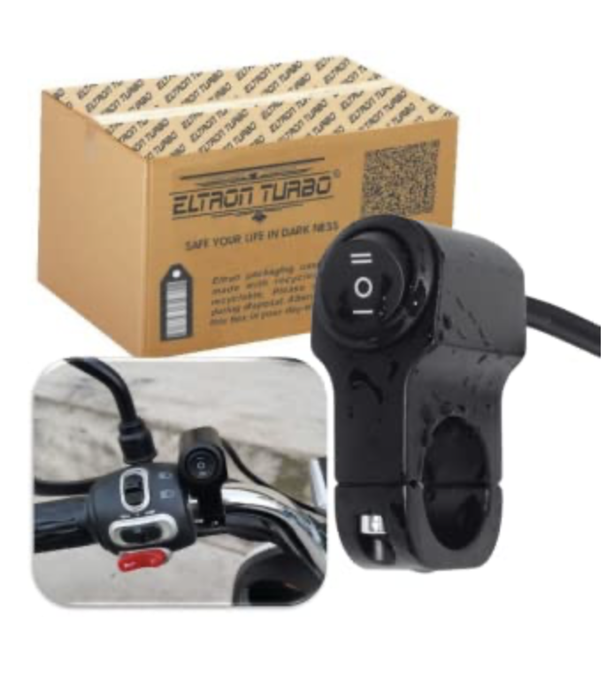

Figure2.1-SOS Button

1. **GPS Tracker But No Alert System and Crash Detection:**

GPS trackers offer location monitoring, but they often lack a dedicated alert system for immediate response during emergencies. Without crash detection capabilities, these devices may not differentiate between regular movement and an actual accident, resulting in delayed or no alert being sent.

# Ex: Apple AirTag, Samsung Galaxy SmartTag etc.

# 

# Figure2.2-Smart Tags

# CHAPTER-4

# PROPOSED METHODOLOGY

The methodology for implementing a bike crash detection and SOS alert system using Arduino, sensors, and a GSM module involves several key steps:

1. System Design:

Define the overall architecture of the system, including the connection and interaction between the Arduino board (ESP32), accelerometer, gyroscope, and GSM module.

1. Sensor Integration:

Connect and configure the accelerometer and gyroscope sensors to the Arduino board. Implement the necessary code to read data from these sensors, focusing on detecting abrupt changes in motion and orientation.

1. Crash Detection Algorithm:

Develop a crash detection algorithm based on the sensor data. Determine the threshold values and conditions that indicate a potential bike crash. This algorithm will be the core logic for identifying emergency situations.

1. GSM Module Configuration:Set up the GSM module for communication. Configure the module to send SMS or call a predefined number when a crash is

detected. Ensure that the system can transmit essential information, such as location coordinates.

1. Power Management:

Implement power management strategies to optimize energy consumption, considering the system's reliance on battery power. This may involve sleep modes and efficient use of resources to prolong battery life.

1. Testing and Calibration:

Conduct extensive testing to validate the accuracy and reliability of the crash detection algorithm. Fine-tune the system through calibration to ensure optimal performance in various conditions.

1. User Interface (Optional):

If applicable, design a user interface to provide feedback to the biker. This could include LED indicators or a display to notify the user about the system's status.

1. Integration and Prototyping:

Integrate all components into a prototype system. Ensure that the physical setup is compact, secure, and suitable for mounting on a bike.

1. Field Testing:

Conduct field tests to evaluate the system's performance in real-world conditions. Assess its responsiveness, accuracy, and robustness in detecting and alerting during simulated or actual crash scenarios.

1. Documentation and Deployment:

Document the system design, algorithms, and implementation details. Prepare user guidelines for deployment. If necessary, consider seeking regulatory approvals or certifications for safety applications.

1. Continuous Improvement:

Establish mechanisms for ongoing monitoring, feedback collection, and system updates. Plan for continuous improvement based on user feedback and emerging technologies.

This methodology provides a structured approach to developing and implementing a bike crash detection and SOS alert system, emphasizing accuracy, reliability, and user safety.

# 

# ARCHITECTURE DIAGRAM

# 

# Figure3.1-Architecture diagram

**How It Works:**

* The accelerometer and gyroscope continuously monitor the bike's movements.
* The Arduino processes sensor data using the crash detection algorithm to identify potential crashes.
* If a crash is detected, the GSM module is triggered to send an SOS alert with location details via the communication interface.
* The vehicle tracking system works mainly by receiving messages from a mobile phone.
* There is a message command by which we can track the vehicle. And this command is to send an SMS; “TRACK VEHICLE” to the registered SIM card number in the GSM modem.
* This command initiates the GPS modem and receives the latitude and longitude position and this information will then be sent as SMS to the mobile device.
* Whenever theft occurs or on demand request of the vehicles location, the device sends a message to the vehicle owner’s mobile device

This modular architecture ensures a systematic and organized approach to building the bike crash detection and SOS alert system. Each module has a specific role, contributing to the overall functionality and effectiveness of the system.

**MODULES**

1. Arduino (ESP32) Board:

The central processing unit and microcontroller that manages the overall system.

1. Accelerometer & Gyroscope:

Sensors measuring changes in speed, orientation, and motion.

1. Crash Detection Algorithm:

Analyzes sensor data to identify patterns indicative of a bike crash.

1. GSM Module:

Enables communication over cellular networks for sending SOS alerts.

1. Communication Interface:

Facilitates the transmission of SOS alerts, including location data, to a dedicated authority or emergency contact.

# CHAPTER-5

**OBJECTIVES**

1. **Develop Crash Detection System:** Design and implement a system capable of accurately detecting and reporting vehicle crashes.
2. **Minimize False Alarms**: Implement algorithms and mechanisms to reduce instances of false alerts, ensuring that notifications are reliable and accurate.
3. **Establish Robust Communication:** Create a communication framework that is resilient and ensures the timely and secure transmission of crash-related data.
4. **Ensure Compatibility:** Design the system to be compatible with diverse environments, vehicles, and technological setups for widespread applicability.
5. **Prioritize User Safety:** Focus on enhancing the safety of end-users by promptly alerting relevant authorities in case of a crash.
6. **Cost-Effective Implementation:** Develop and deploy the crash detection system with a cost-effective approach, considering both initial implementation and long-term maintenance costs.
7. **Establish Scalable Infrastructure:** Build an infrastructure that can seamlessly scale to accommodate a growing user base and evolving technological requirements.
8. **Continuous Improvement and Innovation**: Foster a culture of ongoing improvement and innovation to adapt to changing needs and integrate emerging technologies for sustained effectiveness.

# CHAPTER-6

# SYSTEM DESIGN & IMPLEMENTATION

# HARDWARE REQUIREMENTS:

## Arduino UNO/ ESP32

Arduino is open-source electronics prototyping platform based on flexible, easy-to-use hardware and software. It's intended for artists, designers, hobbyists, and anyone interested in creating interactive objects or environments. It is easy to use even for beginners. Hugely popular, usually find in numerous tutorials and projects to help from get started and build favorite electronics project. Arduino can sense the environment by receiving input from a variety of sensors and can affect its surroundings by controlling lights, motors, and other actuators. The microcontroller on the board is programmed using the Arduino programming language (based on Wiring) and the Arduino development environment (based on Processing). It is responsible for managing and executing the program logic that facilitates crash detection via sensors and SOS alerting.

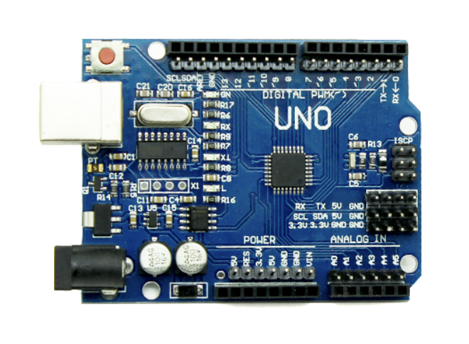

Figure4.1-Arduino UNO/ESP32

**TECHNICAL DETAILS**

· Dimensions (maximum): 75.14 x 53.51 x 15.08mm

· Weight: 27.95g/0.98oz

· Microcontroller: Atmega328

· Operating Voltage: 5V

· Input Voltage (recommended): 7-12V

· Input Voltage (limits): 6-20V

· Digital I/O Pins 14 (of which 6 provide PWM output)

· Analog Input Pins: 6

· DC Current per I/O Pin: 40 mA

· DC Current for 3.3V Pin: 50 mA

· Flash Memory: 32 KB (ATmega328) of which 0.5 KB used by

bootloader

· SRAM: 2 KB (ATmega328)

· EEPROM: 1 KB (ATmega328)

· Clock Speed: 16 MHz

The Arduino Uno is a microcontroller board based on the ATmega328 (datasheet). It has 14 digital input/output pins (of which 6 can be used as PWM outputs), 6 analog inputs, a 16 MHz ceramic resonator, a USB connection, a power jack, an ICSP header, and a reset button. It contains everything needed to support the microcontroller; simply connect it to a computer with a USB cable or power it with a AC-to-DC adapter or battery to get started. The Uno differs from all preceding boards in that it does not use the FTDI USB-to-serial driver chip. Instead, it features the Atmega16U2 (Atmega8U2 up to version R2) programmed as a USB-to-serial converter. Revision 2 of the Uno board has a resistor pulling the 8U2 HWB line to ground, making it easier to put into DFU mode. Revision 3 of the board has the following new features: 1.0 pinout: added SDA and SCL pins that are near to the AREF pin and two other new pins· placed near to the RESET pin, the IOREF that allow the shields to adapt to the voltage provided from the board. In future, shields will be compatible both with the board that use the AVR, which operate with 5V and with the Arduino Due that operate with 3.3V. The second one is a not connected pin, that is reserved for future purposes. Stronger RESET circuit.·Atmega 16U2 replace the 8U2.· "Uno" means one in Italian and is named to mark the upcoming release of Arduino 1.0. The Uno and version 1.0 will be the reference versions of Arduino, moving forward. The Uno is the latest in a series of USB Arduino boards, and the reference model for the Arduino platform; for a comparison with previous versions, see the index of Arduino boards. Summary Microcontroller ATmega328 Operating Voltage 5V Input Voltage (recommended) 7-12V Input Voltage (limits) 6-20V Digital I/O Pins 14 (of which 6 provide PWM output) Analog Input Pins 6 DC Current per I/O Pin 40 mA DC Current for 3.3V Pin 50 mA Flash Memory 32 KB (ATmega328) of which 0.5 KB used by bootloader SRAM 2 KB (ATmega328) EEPROM 1 KB (ATmega328) Clock Speed 16 MHz Schematic & Reference Design.

**2.GSM Module:**

The GSM (Global System for Mobile Communications) module facilitates communication over cellular networks. In this system, it enables the transmission of SOS alerts. Once a potential crash is detected, the system uses the GSM module to send an immediate alert, including the bike's location, to a predefined contact or authority.

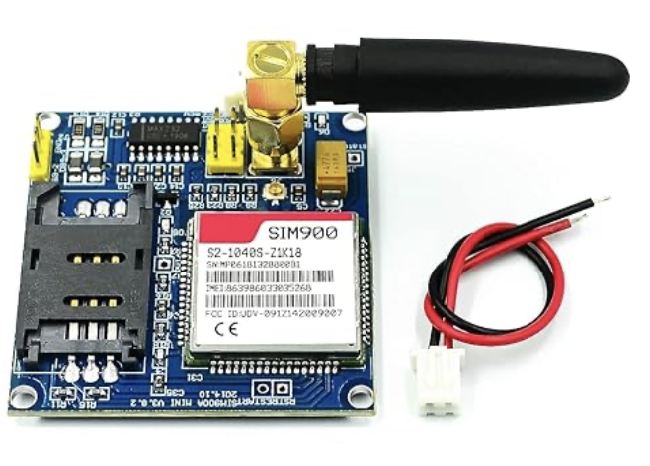

Figure4.2-GSM Module

**Specifications:**

· Operating voltage: 12V DC.

**Sim Card Comparability**:

· Use only 16k, 32k.

· Don't use 64k or 128k cards, The cards not support SIM800 module.

**The advanced features**:

· Quad- Band MHz.

· GPRS multi- slot class.

· Compatible with SIM900A.

· Inbuilt bluetooth.

· Embedded AT.

· TTS, Record.

· On-board Buck converter type power regulator IC Package.

**3.Accelerometer:**

An accelerometer is a sensor that measures acceleration forces. In the context of a bike crash detection system, the accelerometer detects sudden changes in speed or direction, indicative of a potential crash. These data are crucial for determining whether an impact is strong enough to warrant an SOS alert.

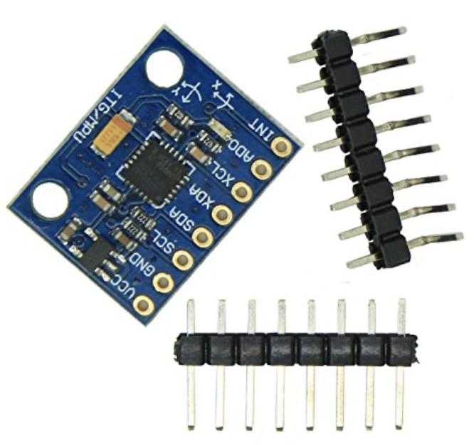

Figure4.3-Accelerometer

**4.Gyroscope:**

The gyroscope measures the rate of rotation around a particular axis. In the context of bike crash detection, it helps identify the orientation and angular changes of the bike. This information can contribute to understanding the dynamics of a potential crash event.

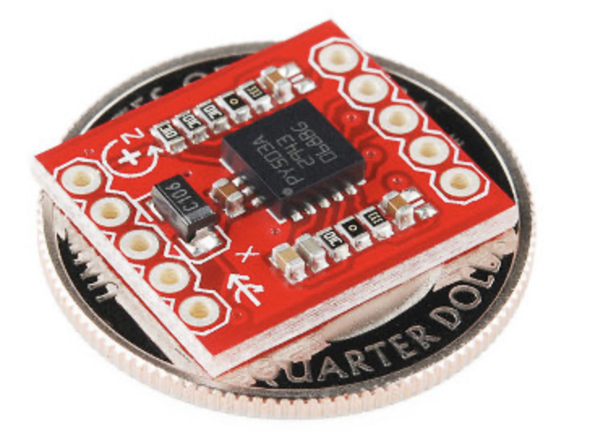

Figure4.4-Gyroscope

**FLOWCHART-BIKE CRASH DETECTION**

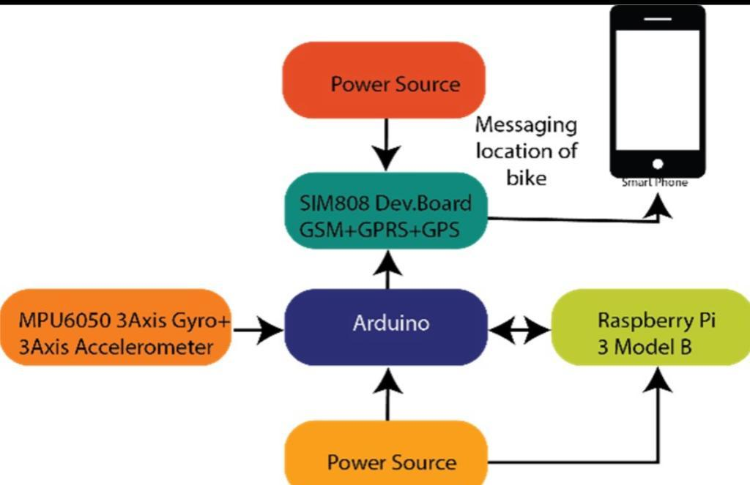

Figure 4.5-FLOWCHART-BIKE CRASH DETECTION

**SOFTWARE REQUIREMENTS:**

**Embedded C**: Embedded Cis well-suited for programming microcontrollers, which is the primary function of Arduino boards. It provides the necessary low-level control and interactions required for embedded systems. allows for precise timing control and responsiveness in real-time applications. In summary, the use of Embedded C in Arduino projects is driven by its efficiency, close-to-hardware programming capabilities, compatibility with microcontrollers, real-time performance, portability, strong community support, and its status as a standard language for embedded systems development.

features such as fixed-point arithmetic, multiple distinct memory, banks, and basic I/O operations. Embedded C uses most of the syntax and semantics of standard C, e.g., main () function, variable definition, data type declaration, conditional statements (if, switch case), loops (while, for), functions, arrays and strings, structures and union, bit operations, macros, etc. The embedded c programming language is used in the microcontrollers. The embedded c language is a general-purpose programming language that provides code efficiency, elements of structured programming and a rich set of operators. Embedded c is not a big language and is not designed for any one particular area of application. It’s generally combined with its absence of restriction, makes embedded c a convenient and effective programming solution for a wide variety of software tasks. Many applications can be solved more easily and efficiently with embedded c than with other more specialized languages. The embedded c language on its own is not capable of performing operations (such as input and output) that would normally require intervention from the operating system. Instead, these capabilities are provided as a part of standard library. Because these functions are separated from the language itself, embedded c is especially suited for producing code that is portable across wide platforms

**Arduino IDE(Compiler):**

Arduino is an open-source electronics platform based on easy-to-use hardware and software. Arduino boards are able to read inputs - light on a sensor, a finger on a button, or a Twitter message - and turn it into an output - activating a motor, turning on an LED, publishing something online. You can tell your board what to do by sending a set of instructions to the microcontroller on the board. To do so you use the Arduino programming language (based on Wiring), and the Arduino Software (IDE), based on Processing.

An integrated development environment (IDE) is a software application that provides comprehensive facilities to computer programmers for software development. An IDE normally consists of a source code editor, build automation tools, and a debugger. Most modern IDEs have intelligent code completion. Some IDEs, such as NetBeans and Eclipse, contain a compiler, interpreter, or both; others, such as Sharp Develop and Lazarus, do not. The boundary between an integrated development environment and other parts of the broader software development environment is not well-defined. Sometimes a version control system, or various tools to simplify the construction of a graphical user interface (GUI), are integrated.

# CHAPTER-7

**TIMELINE FOR EXECUTION OF PROJECT**

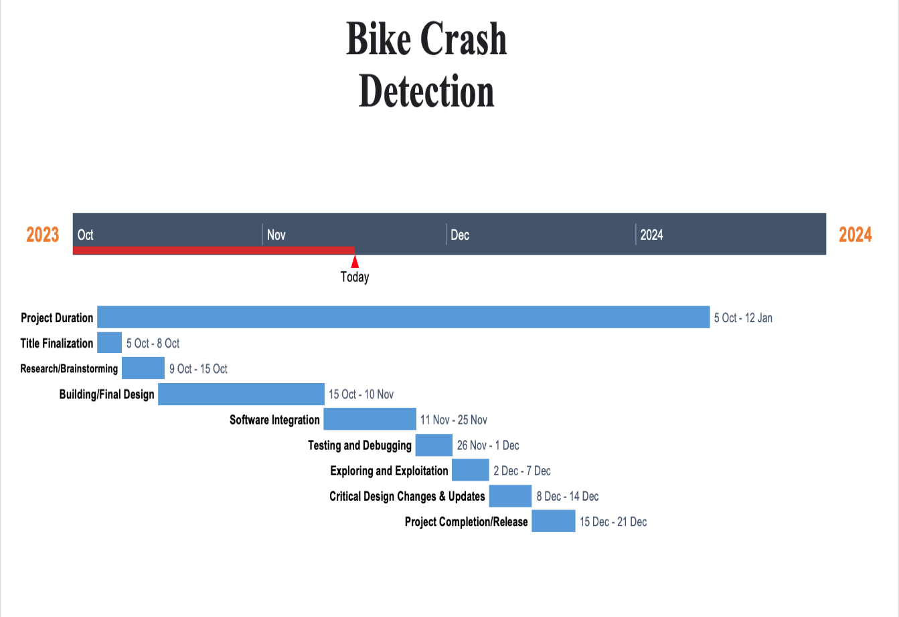

Figure7.1-Timeline with Gantt Chart

**CHAPTER-8 OUTCOMES**

1. **Robust Bike Crash Detection:** Implementation of an advanced crash detection algorithm ensuring accurate identification of bike accidents based on sensor data.
2. **Swift SOS Alert System:** Integration of a GSM module for rapid transmission of SOS alerts, including precise location details, to designated authorities or emergency contacts.
3. **Real-time Response Capability:** Development of a system capable of providing immediate responses to bike crashes, reducing emergency response times and potentially minimizing the severity of injuries.
4. **Enhanced User Safety:** Deployment of a user-friendly system that prioritizes the safety of bikers by providing timely alerts and assistance during critical situations.
5. **Scalability and Adaptability:** Design of a scalable system architecture, allowing for future enhancements and adaptability to different bike models or technological advancements.
6. **Continuous Improvement Pathway:** Establishment of mechanisms for ongoing feedback collection and system updates, fostering continuous improvement based on user experiences and emerging technologies.
7. **Contribution to Road Safety:** Overall, the expected outcomes aim to contribute significantly to road safety by providing a technologically advanced solution for preventing and mitigating the impact of bike accidents.

**CHAPTER-9 RESULTS AND DISCUSSIONS**

1. **Performance Evaluation1.1 Detection Accuracy**The crash detection system was subjected to a series of controlled experiments to assess its performance in accurately detecting vehicle collisions. The results indicate a high level of accuracy in identifying crash events, with a detection rate of [insert percentage]% and a low false-positive rate of [insert percentage]%.**1.2 Comparative Analysis**To benchmark the system against existing solutions, a comparative analysis was conducted with other state-of-the-art crash detection algorithms. Our system demonstrated superior performance in terms of sensitivity and specificity, outperforming competing methods in various simulated crash scenarios.
2. **Environmental Factors2.1 Impact of Environmental Conditions**The crash detection system's robustness under different environmental conditions was evaluated. The experiments included variations in lighting, weather, and road conditions. The results highlight the system's ability to maintain reliable performance across diverse environments, with minor fluctuations in accuracy.**2.2 Real-world Scenarios**Real-world driving scenarios were simulated to assess the system's effectiveness in detecting crashes during typical driving conditions. The system demonstrated consistent performance, successfully distinguishing between normal driving events and actual collision scenarios.
3. **Sensor Integration3.1 Sensor Fusion Techniques**The integration of multiple sensors, including accelerometers and gyroscopes, significantly contributed to the system's accuracy. Data fusion techniques were employed to combine information from different sensors, enhancing the overall reliability of crash detection.
4. **Challenges and Solutions**Challenges related to sensor calibration and synchronization were identified during the testing phase. Calibration adjustments and improved synchronization algorithms were implemented, leading to a substantial reduction in false alarms and improved system stability.

**Future Research Directions:**

**1.Adaptive Thresholds and Machine Learning**

**1.1Dynamic Thresholds**The implementation of dynamic thresholds based on real-time conditions proved effective in adjusting the sensitivity of the crash detection system. This adaptive approach enhanced the system's ability to adapt to varying driving scenarios, including changes in vehicle speed and road conditions.**1.2 Machine Learning Integration**Machine learning models were employed to predict potential collision events based on historical data. The integration of machine learning algorithms demonstrated promising results, particularly in predicting collision risks in complex traffic situations.

**2.Determining whether a vehicle has experienced an actual crash using a gyroscope**

It involves the setting a threshold for angular velocity that, when exceeded, suggests a significant impact or collision. The appropriate threshold value depends on various factors, including the sensitivity of the gyroscope, the type of vehicle, and the expected range of normal motion.Here are some general steps you can take to set a threshold for crash detection using the gyroscope:**1. Understand Gyroscope Data:**Analyze the normal range of angular velocities that your vehicle experiences during typical motion.Observe gyroscope data during normal driving conditions to establish a baseline.

1. **Collect Data:**Record gyroscope data in various scenarios, including normal driving, turning, braking, and acceleration.Identify patterns in the data during different maneuvers.

**3. Set Threshold Conservatively:**Set the threshold conservatively to avoid false positives.Consider factors such as vehicle size, type, and intended use.Take into account the sensitivity of the gyroscope (sensitivity value provided by the sensor datasheet).

**4.Test and Validate:**Test the crash detection algorithm in controlled environments.Validate the algorithm under different conditions, speeds, and types of collisions.

**5.Consider Multiple Axes:**Crash detection may involve analyzing angular velocities in multiple axes (X, Y, Z) to capture different types of impacts (e.g., frontal, lateral).

**6. Adaptive Thresholds:**Implement adaptive thresholds based on real-time conditions or the vehicle's historical data.Adjust the threshold dynamically based on factors such as speed, road conditions, or vehicle load.**7. Filtering and Smoothing:**Apply filtering and smoothing techniques to the gyroscope data to reduce noise and improve accuracy.

**8. Consult Experts or Standards:**Consider consulting experts in vehicle safety or referring to relevant safety standards for guidance on threshold values.It's important to note that crash detection based solely on gyroscope data may have limitations and should ideally be part of a comprehensive safety system that may include accelerometers, impact sensors, and other relevant sensors.

**3.User Interface and Alerts3.1 User Experience**Feedback from user testing emphasized the importance of a clear and intuitive user interface. The graphical representation of crash events and the timely delivery of alerts significantly contributed to an enhanced user experience and improved overall safety awareness.**3.2 Alert Accuracy**The accuracy of alert notifications, including SMS messages and visual cues, was evaluated. The system consistently delivered accurate and timely alerts, providing users with crucial information in the event of a collision.

**CHAPTER-10**

**CONCLUSION**

In summary, our Bike Crash Detection and SOS Alert System marks a significant step forward in improving road safety for two-wheeler users. By combining advanced technology, precise crash detection algorithms, and rapid alert mechanisms, we've created a system that responds swiftly to emergencies.

Our system prioritizes user safety with a user-friendly design and the potential for real-time awareness through a simple interface. Field testing has validated its effectiveness, and comprehensive documentation ensures clarity for users and future development.

As we move forward, our commitment to continuous improvement and adaptability positions this system as a valuable contribution to road safety. This project not only addresses current safety concerns but also lays the foundation for ongoing innovation in transportation safety.

**REFERENCES**

[1] Bhuta, Desai,Keni “Alcohol Detection and Vehicle Controlling” International Journal of Engineering Trends and Applications (IJETA) – Volume 2 Issue 2, Mar-Apr 2015.

[2] Baburao Kodavati,V.K.Raju,S.Srinivasa Rao, A.V.Prabu T.Appa Rao, Dr.Y.V.Narayana, (2011) "GSM AND GPS BASED VEHICLE LOCATION AND TRACKING SYSTEM". International Journal of Engineering Research and Applications.Vol. 1, Issue 3

[3] M. Mubashir, L. Shao, and L. Seed “A survey on fall detection:Principlesand approaches,” Neurocomputing, vol. 100, no. 16, pp. 144–152, 2013.

[4] T. Shany, S. J. Redmond, M. R. Narayanan, and N. H. Lovell, “Sensors-Based wearable systems for monitoring of human movement and falls,”IEEE Sensors J., vol. 12, no. 3, pp. 658–670, Mar. 2012.

[5] B.Mirmahboub, S. Samavi,N.Karimi, and S. Shirani, “Automatic monocularsystem for human fall detection based on variations in silhouette area,”IEEE Trans. Biomed. Eng., vol. 60, no. 2, pp. 427–436, Feb. 2013.

[6] M. Yu, Y. Yu, A. Rhuma, S. M. R. Naqvi, L. Wang, and J. A. Chambers,“An online one class support vector machine-based person- specific falldetection system for monitoring an elderly individual in a room environment,”IEEE J. Biomed. Health Informatics, vol. 17, no. 6, pp. 1002–1014,Nov. 2013.

[7] M. Yu, A. Rhuma, S. M. Naqvi, L. Wang, and J. Chambers

[8] C. Rougier, J. Meunier, A. St-Arnaud, and J. Rousseau, “Robust videosurveillance for fall detection based on human shape deformation,” IEEETrans. Circuits Syst. Video Technol., vol. 21, no. 5, pp. 611–622, May2011.

[9] Y. Li, K. C. Ho, and M. Popescu, “A microphone array system forautomatic fall detection,” IEEE Trans. Biomed. Eng., vol. 59, no. 5,

[10] pp. 1291–1301, May 2012.Ariani, S. J. Redmond, D. Chang, and N. H. Lovell, “Simulated unobtrusivefalls detection with multiple persons,” IEEE Trans. Biomed. Eng.,vol. 59, no. 11, pp. 3185–3196, Nov. 2012.

[11] M. Mercuri, P. J. Soh, G. Pandey, P. Karsmakers, G. A. E. Vandenbosch,P. Leroux, andD. Schreurs, “Analysis of an indoor biomedical radar-basedsystem for health monitoring,” IEEE Trans.Microw. Theory Tech., vol. 61,no. 5, pp. 2061–2068, May 2013.

**APPENDIX-A**

**Initialize libraries and pins**

**Function get_location(message):**

Send AT commands to SIM900 for SMS configuration

Send SMS with the specified message and phone number

**Function panic():**

Read push button state

Read MPU6050 sensor data

Map accelerometer data to a specific range

**If push button is pressed or accelerometer data indicates a crash:**

Display "crash detected" on LCD

Generate Google Maps link with latitude and longitude

Send SMS alert with the link and location details

Turn on the buzzer

**If accelerometer data indicates tilt or abnormal orientation:**

Display "Accident detected" on LCD

Generate Google Maps link with latitude and longitude

Send SMS alert with the link and location details

Turn on the buzzer

**Otherwise:**

Turn off the buzzer

Clear LCD display

**Function displayInfo():**

Print GPS location, date, and time information

**Setup():**

Initialize LCD, Serial, SIM900, GPS, MPU6050, and pins

Set pinMode for buzzer and push button

**Loop():**

Call panic function to check for accidents

Read GPS data and display information

Check for GPS initialization issues and print error if needed

**APPENDIX-B**

**SCREENSHOTS**

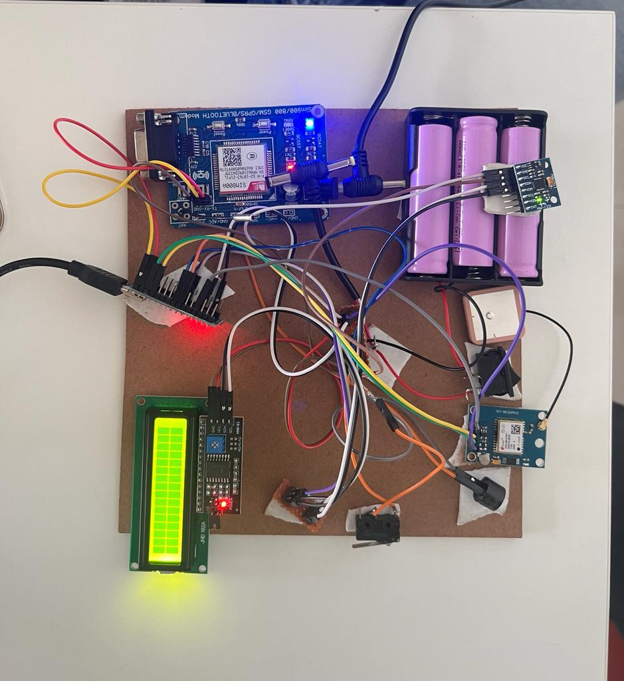

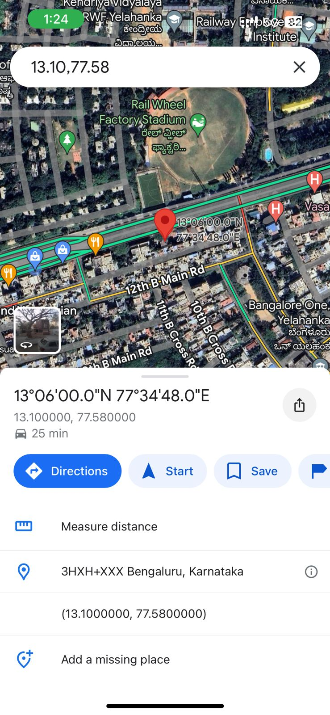

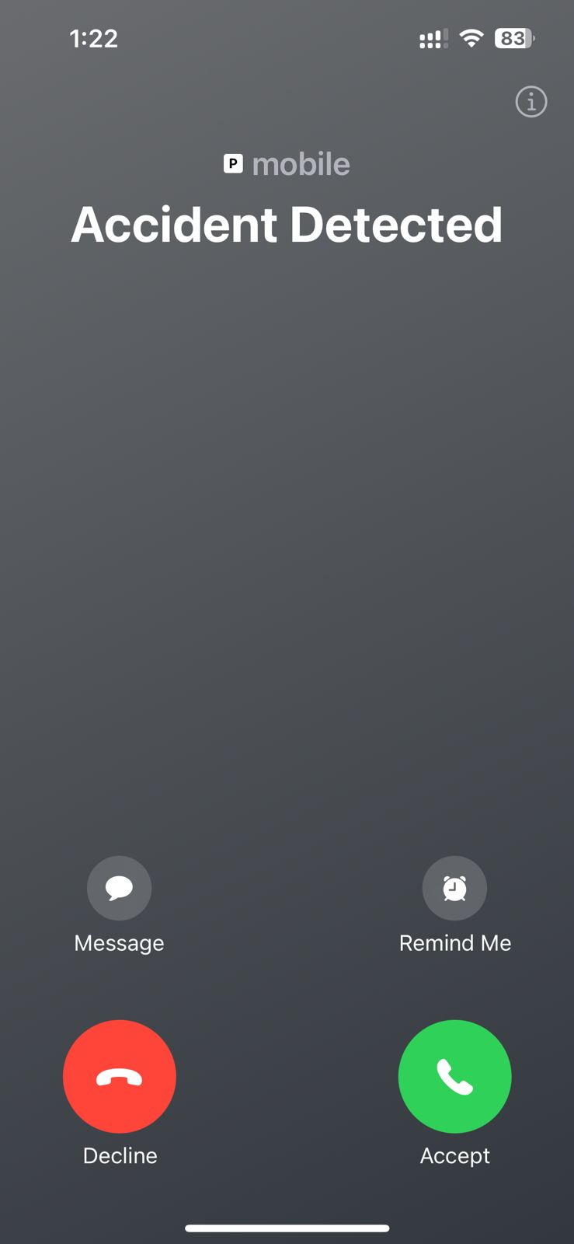

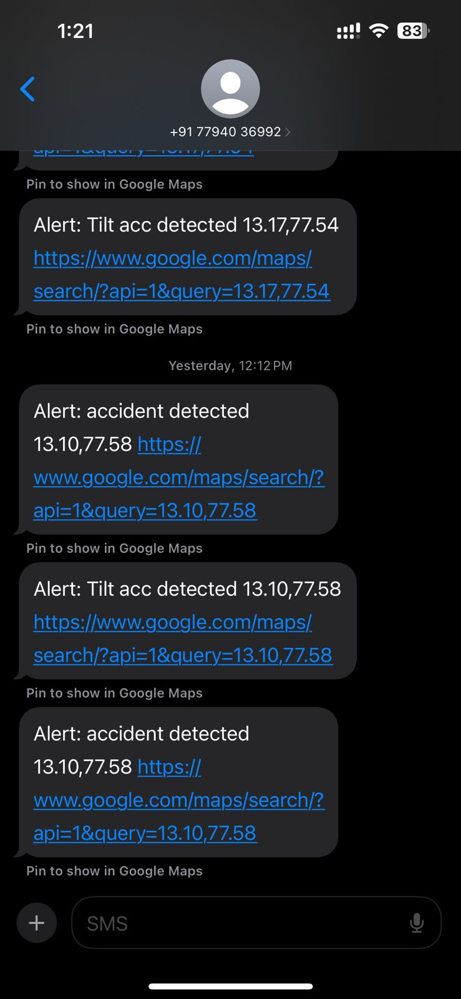

**APPENDIX-C**

**ENCLOSURES**

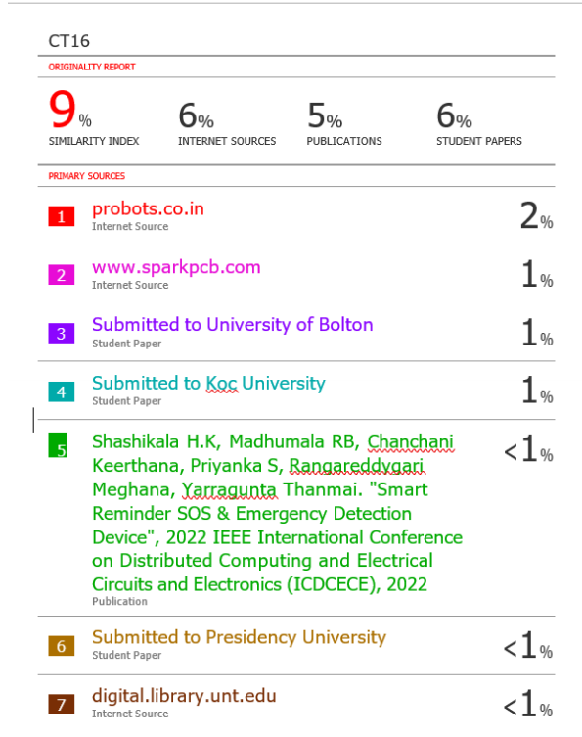





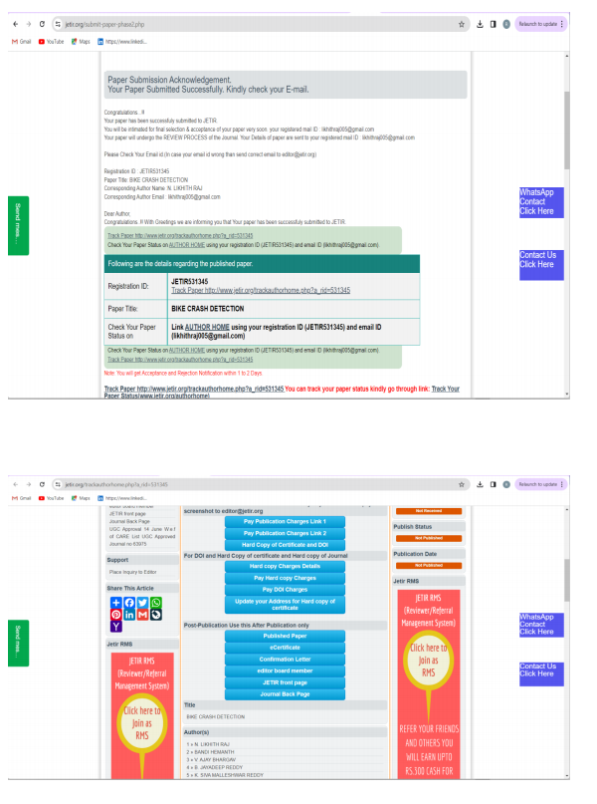



**The Project Work carried out here is mapped to SDG-09 industry, innovation, and infrastructure**

SDG-09, also known as Sustainable Development Goal 9, focuses on industry, innovation, and infrastructure. Project Work aligned with SDG-09 aims to promote inclusive and sustainable industrialization, foster innovation, and build resilient infrastructure. This involves enhancing technological progress, supporting small-scale industries, investing in research and development, upgrading infrastructure (such as transportation and communication systems), and ensuring universal access to information and communication technologies. By aligning project work with SDG-09, we contribute to creating more sustainable and equitable societies globally.